Answers to Questions from TT 6.1

Name: Tran Quang Huy
Student ID: 106212636

Hand execution using a trace table

Demonstrate how the following code is executed in the computer.
Name for the function: sum_list

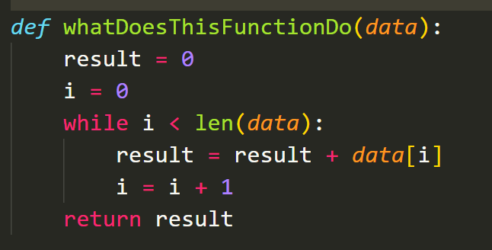

Draw and complete a trace table for the following two sets of data and place the result in the table below:

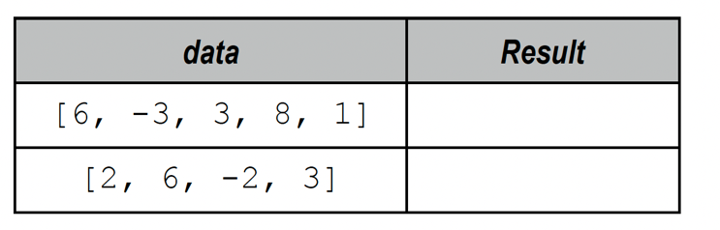
Result 1 : 15
Result 2: 9

Once you have completed your trace tables (below) write the name you chose for the function above:

________________________________________________________

Place your trace tables below:

For data set: [6, -3, 3, 8, 1]

Loop | i | Result
First loop | 0 | 0
1 | 1 | 6
2 | 2 | 5
3 | 3 | 6
4 | 4 | 14
5 | 5 | 15

For data set [2, 6, -2, 3]

Loop | i | Result
First loop | 0 | 0
1 | 1 | 2
2 | 2 | 8
3 | 3 | 6
4 | 4 | 9

